Copy adjustments

New headline
You’re building something real.
We align everything it needs to move.
- New subhead
Bianomics brings strategy, story, people, and operations into one coherent system, so ambitious work can earn belief, build momentum, and last.
- Cosmetic adjustments
1. Capitalize all the words below Replace Brand Strategy with Brand & Marketing Strategy
Replace Public Relations with Public Relations & Crisis Management (this is lime green)
Replace Conferences and launches with Event Architecture & Management
Replace Operations Systems with Operational Blueprints
See if we can coordinate coloring in a cohesive pattern
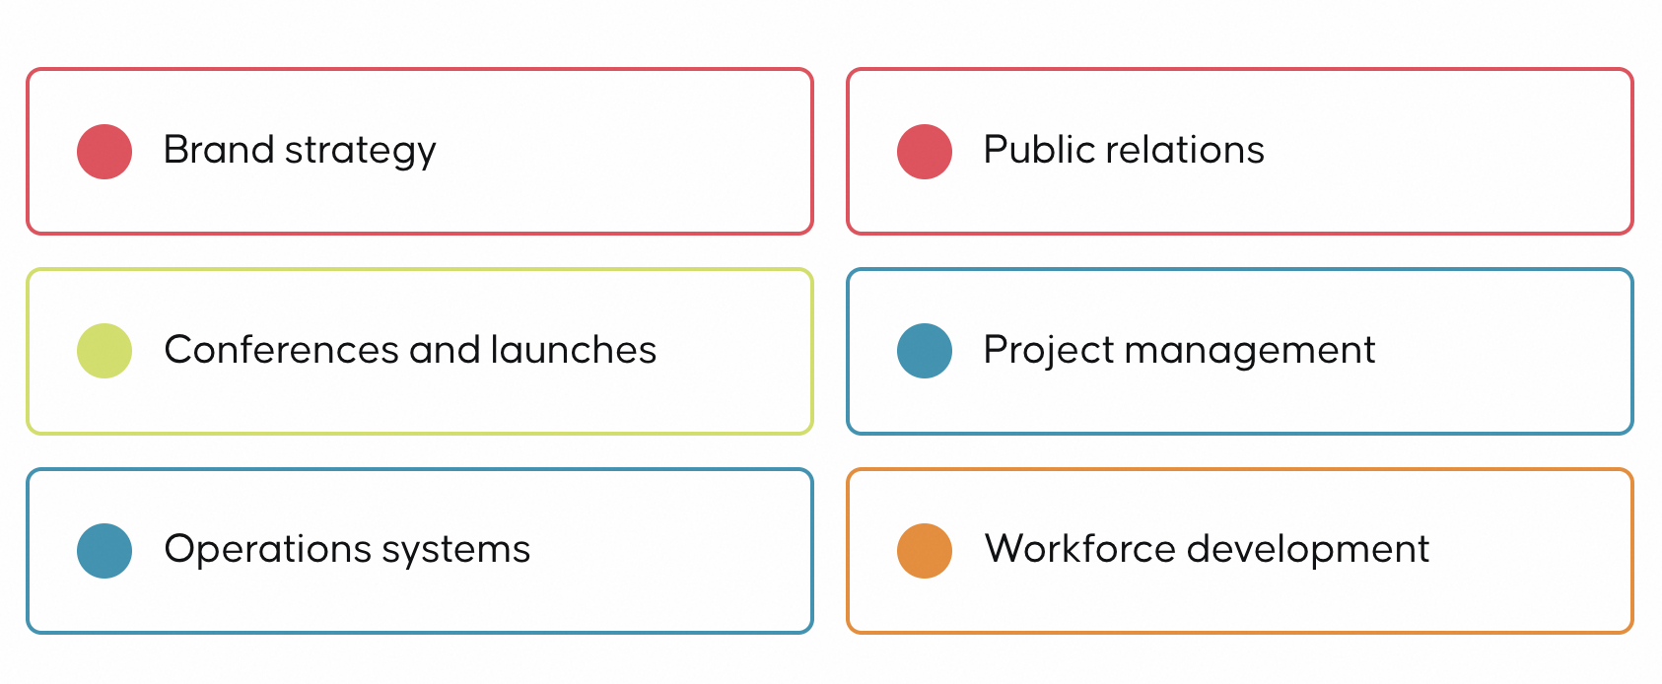

- 2. Copy adjustments
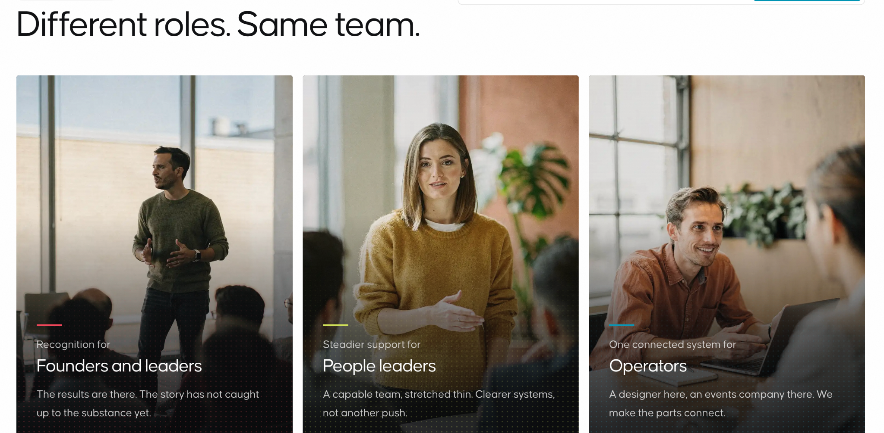
Rethinking this:
New headline:
Purpose needs a voice loud enough to be heard. A workforce strong enough to carry it. We build both.
Cards:
Card 1
Marketing, PR, and infrastructure guidance for
Social impact and purpose-driven organizations
The work is true. We make it undeniable, we put it on the stage it deserves, and we make sure every piece moves toward the same vision.
Card 2
Workforce development for
Organizations and at-risk populations
A career does not start with a job posting. It starts with being seen. We build what gets someone from ready to hired, and further.

- OUR PROCESS
- 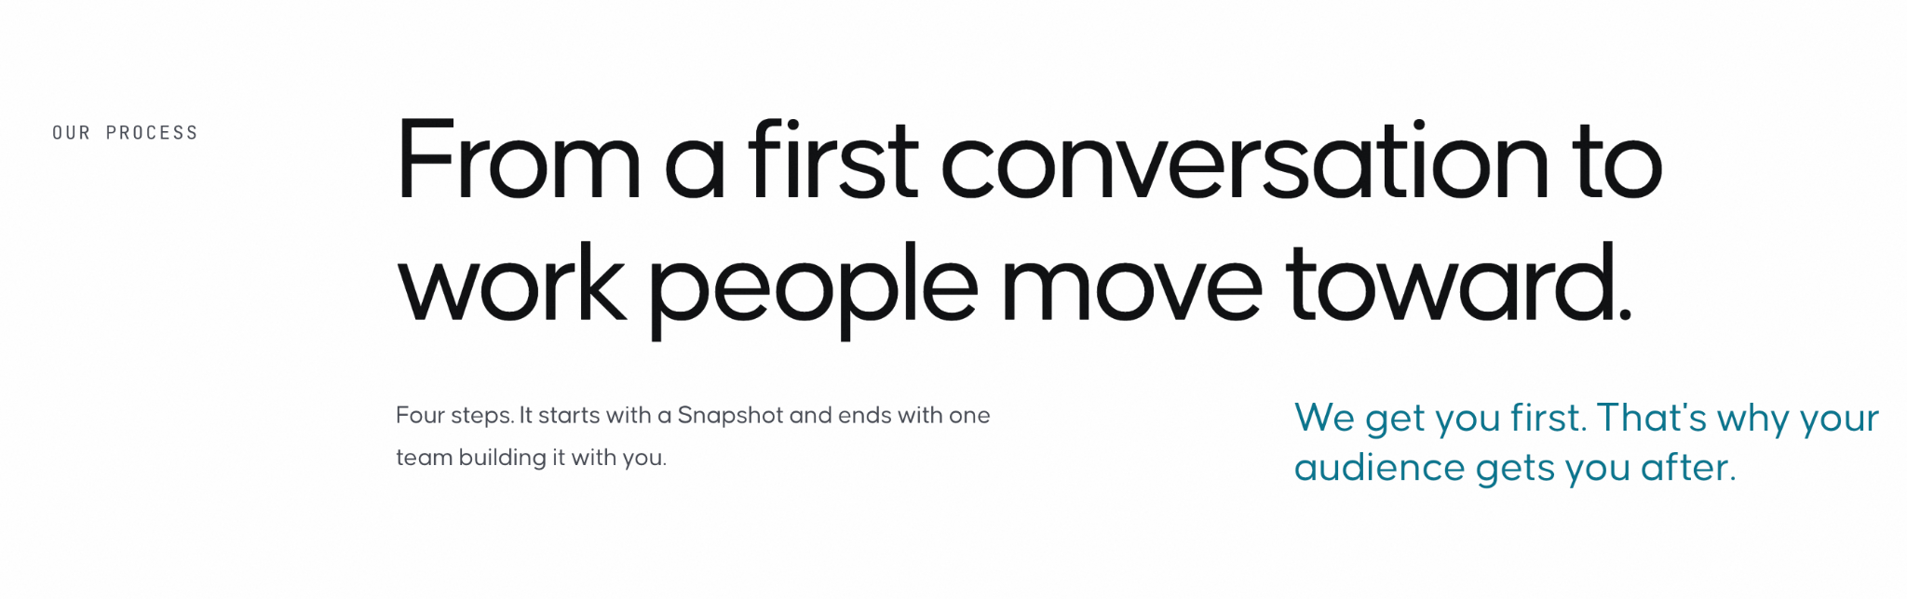
- Four steps to align it. The same people through all of them.
It starts with a Snapshot, a senior read of where your story, systems, and people actually stand, and ends with senior people building alongside you.
(remove the ‘from a first conversation’, and ‘we get you first’ lines)
- Featured projects
Here are the case studies - copy is ready - let’s hold on the longer case study until phase 2. Currently developing the mockups for the visual but at least Ive curated!! Is this too much? Can we maybe do it in two columns?
GROUNDWORK YOUTH PROGRAM
Multi-State Licensing
Workforce Development · Curriculum Design · Program Licensing
A curriculum built once, now running in four states
What started in El Paso didn't stay in El Paso.
We built the youth curriculum, then built it to travel. Georgia, New Jersey, New York, and Texas now ran the same methodology under their own name. Proof that what works here works anywhere.

BEYOND DUTY
Groundwork · Flagship Program
Program Design · Brand Strategy · Public Relations · Presentation Design
A veteran program built to thaw a frozen nervous system.
From first cohort to a program running through 2027.
We designed the curriculum, built the sales kit and partnership deck that earned it sponsor funding, and ran the press campaign that carried it into public view. Still running. Still growing.

WORKFORCE SOLUTIONS BORDERPLEX
Groundwork · Systems Partner
Brand Audit · Strategy · Communications Infrastructure · Project Management · Workforce Development
The workforce board that handed us the whole operation
Staff development and youth readiness, backed by the infrastructure to run it without us.
Continuation of brand strategy, communications guidelines, a mapped consumer journey, and the project management systems underneath all of it. Not a workshop vendor. A comms department they didn't have to build themselves.

THE CHALLENGE FOUNDATION EL PASO
Vision Lab
Brand Audit · Public Relations · Communications Strategy · Leadership Empowerment
A nonprofit trained to run its own comms, not rent ours forever
We didn't just reinforce the brand. We taught the team to hold it.
A full brand audit and reinforcement, an active public relations practice, and communications strategy training built so leadership could manage the message themselves. The kind of work that's supposed to make you obsolete, on purpose.

EL PASO LEADERSHIP ACADEMY (EPLA)
Groundwork + Vision Lab
Workforce Development · Purpose Alignment Workshops · Public Relations · Campaign Strategy
Workshops and press, working the same story from two directions
One campaign, one purpose-alignment curriculum, one team building both.
We built customized workforce and purpose alignment workshops from the ground up, then ran the public relations campaign that put the results in front of the region.

READYONE INDUSTRIES
Blueprint · Operations · Vision Lab
HR Video Production · Staff Messaging Training · Campaign Strategy · Communications Training · Workflow Design
Built by Ability, told the way it deserved to be told
HR video, staff messaging, and the campaign carrying a mission-driven employer's story.
We produced the HR video series, trained staff on messaging that actually sounds like people, produced the Built by Ability campaign, and built the communications training and workflow systems that keep it running without a consultant in the room.

WAY OUT WEST
Stage
Production Support · Public Relations
Production support for a campaign on festival relocation built to be seen
The press and the production, handled by Bianomics.
We supported the production campaign end to end and ran the public relations alongside it, so the work and the story of the work moved at the same pace.

DRIVEN AGAINST SILENCE
Vision Lab · Nonprofit Consulting
Nonprofit Consulting · Brand Identity · Messaging · Strategic Planning
A nonprofit that needed a strategy, not just a logo
Brand identity, messaging, and the plan to carry both forward.
We built the brand identity and the messaging behind it, then sat down and are supporting the strategic plan build, so the organization has a direction, not just a look.

Also, I think we should include some of the websites we’ve done - is that overkill on featured projects?
And I am creating mockups for:
https://www.scottishluxuryexperience.com/
https://www.tennilytics.com/
https://www.genroks.com/
Inquire for industry specific models as our developer has worked on several!

